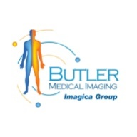Top 4 Benefits of Advanced Digital X-ray at Butler Medical Imaging. (08) 9544 3999

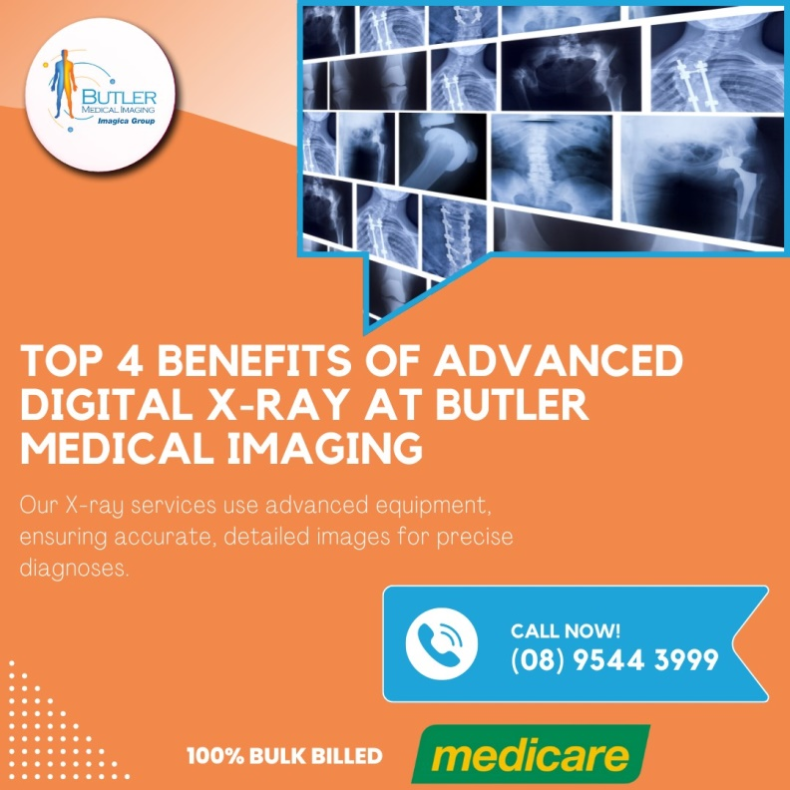For over three decades, medical imaging, particularly advanced digital X-ray imaging, has revolutionized healthcare. High-end diagnostic tools like ultrasounds and X-rays have become essential for identifying ailments early, improving patient outcomes significantly. Let’s explore the top four benefits of advanced [digital](https://butlerimaging.com.au/x-ray/) X-ray imaging.

**1. Improved Diagnosis**

Advanced digital X-ray imaging offers a more precise and comprehensive diagnosis. These imaging techniques allow healthcare providers to visualize internal structures in remarkable detail, facilitating a better understanding of a patient’s condition. This is especially valuable in diagnosing conditions that are not easily detectable through physical examination alone.

**Non-Invasive and Painless**

One of the most significant advantages of [digital X-ray](https://butlerimaging.com.au/x-ray/) imaging is its non-invasive nature. Procedures such as ultrasounds, MRIs, and CT scans do not require incisions or invasive measures. These imaging techniques are generally painless and require minimal to no special preparation, making them convenient for patients.

**Detailed Internal Examination**

Advanced digital X-ray imaging can examine various internal structures, including joints, muscles, tendons, and organs. For instance, ultrasounds, commonly used during pregnancy, monitor the baby’s growth and detect potential complications. Early detection of anomalies can lead to timely treatment, ensuring better health outcomes for both the mother and the baby.

**2. Affordable Healthcare**

Digital X-ray imaging plays a crucial role in reducing [healthcare costs](https://butlerimaging.com.au/x-ray/) by enabling early and accurate diagnosis. When doctors can identify the root cause of an ailment promptly, they can recommend appropriate treatments that often avoid the need for expensive surgeries or prolonged hospital stays.

**Avoidance of Invasive Procedures**

Advanced imaging techniques allow physicians to make informed decisions about the necessity of invasive procedures. For example, a digital X-ray can reveal whether a patient requires angioplasty or cardiac catheterization. In many cases, the need for surgery is ruled out, and the condition is managed with regular oral medication and non-invasive treatments.

**Cost-Effective Diagnostic Tool**

By diagnosing conditions early, advanced digital X-ray imaging helps avoid the high costs associated with late-stage [treatments](https://butlerimaging.com.au/x-ray/) and surgeries. This not only saves patients from financial burdens but also ensures they receive timely and effective care.

**3. Safety and Effectiveness**

Advanced digital X-ray imaging has undergone significant advancements, making it safer and more effective than ever before. Modern imaging equipment uses low radiation levels, minimizing potential risks while providing high-quality images.

**Reduced Radiation Exposure**

One of the primary concerns with traditional X-ray imaging was the exposure to radiation. However, extensive research and innovation have led to the development of [high-precision](https://butlerimaging.com.au/x-ray/), low-radiation imaging machinery. These advancements ensure patient safety while enhancing the diagnostic capabilities of healthcare providers.

**High Precision Imaging**

The accuracy of advanced digital X-ray imaging allows physicians to make quick and correct diagnoses. High-resolution images provide detailed views of internal structures, enabling doctors to detect even minor abnormalities. This precision is crucial for effective treatment planning and monitoring.

**4. Enhanced Patient Care**

The integration of advanced digital X-ray imaging into healthcare practices has significantly improved patient care. By offering [accurate diagnoses](https://butlerimaging.com.au/x-ray/), reducing the need for invasive procedures, and ensuring patient safety, these imaging techniques contribute to a higher standard of care.

**Streamlined Treatment Processes**

With precise imaging, doctors can develop targeted treatment plans tailored to individual patients. This personalized approach enhances the effectiveness of treatments and improves patient outcomes. Moreover, the ability to monitor the progress of a condition through regular imaging ensures that any changes are detected promptly, allowing for timely interventions.

**Improved Patient Experience**

The non-invasive and painless nature of advanced digital X-ray imaging enhances the overall patient experience. Patients are more likely to comply with recommended imaging procedures when they know the process is comfortable and safe. This compliance is essential for [accurate diagnosis](https://butlerimaging.com.au/x-ray/) and effective treatment.

**Why Choose Butler Medical Imaging?**

We are local and a Privately-owned medical Clinics that offers the highest quality medical and Imaging Services in the Butler Medical Imaging region. We are the leaders in [Bulk Billing](https://butlerimaging.com.au/appointment/) with the real benefit of no ‘Out of Pocket’ expenses for you.

**Your Next Step**

Please ensure that you have your Medicare card and referral with you and pop into our location for your consultation. If you have any questions at all, please feel free to contact us on [+61 8 9544 3999](https://butlerimaging.com.au/appointment/) as we are here to help.